Have you ever imagined that the cherubim on the Ark (Exo 25:18), in the oracle (1Ki 6:23-28), on the curtains (Exo 26:1), the vail (Exo 26:31), the walls (1Ki 6:29), the doors (1Ki 6:32,35), the borders and plates of the bases (1Ki 7:29,35) were depicted as winged men like the angels of modern iconography?

In the visions of the prophet Ezekiel we’re given an interesting parallel that can be easy to miss. But, that detail is what is integral for dismantling centuries of mistranslation (3rd century AD Rabbinic traditions) and worldly influence (Greco-Roman; Eros, Cupid, Nike) as to what a Cherub (singular) or Cherubim (plural) actually looked like.

In Ezekiel 10:14 it is written that the living creatures had four faces:
- a Cherub
- a Man
- a Lion
- an Eagle

Ezekiel 10:14
And every one had four faces: the first face was the face of a cherub, and the second face was the face of a man, and the third the face of a lion, and the fourth the face of an eagle.

Then, 8 verses later we’re told that their faces are exactly the same as the faces of the living creatures in Ezekiel chapter 1:

Ezekiel 10:22
And the likeness of their faces was the same faces which I saw by the river of Chebar, their appearances and themselves: they went every one straight forward.

Now, if we look back to chapter 1 the list of faces is slightly different:
- a Man
- a Lion
- an Ox
- an Eagle

Ezekiel 1:1,10
¹ Now it came to pass in the thirtieth year, in the fourth month, in the fifth day of the month, as I was among the captives by the river of Chebar, that the heavens were opened, and I saw visions of God.
¹⁰ As for the likeness of their faces, they four had the face of a man, and the face of a lion, on the right side: and they four had the face of an ox on the left side; they four also had the face of an eagle.

And since we’re told the faces are the same, but one of them is called by two different names, this teaches us what the face of the cherub looked like: an ox!

Ezekiel 1 | Ezekiel 10
Cherub | Ox
Man | Man
Lion | Lion
Eagle | Eagle

Now that we know what the cherubim actually looked like, suddenly the architecture elsewhere starts to make more sense:

1 Kings 7:23-25 (the brass laver of Solomon’s temple)
²³ And he made a molten sea, ten cubits from the one brim to the other: it was round all about, and his height was five cubits: and a line of thirty cubits did compass it round about.
²⁴ And under the brim of it round about there were knops compassing it, ten in a cubit, compassing the sea round about: the knops were cast in two rows, when it was cast.
²⁵ It stood upon twelve oxen, three looking toward the north, and three looking toward the west, and three looking toward the south, and three looking toward the east: and the sea was set above upon them, and all their hinder parts were inward.

Elsewhere in tradition, we learn that the standards of each tribal camp around the tabernacle (Numbers 2) line up perfectly with the Bible in ways we might not expect:

Camped around the tabernacle | Tribe | Standard
East | Judah | Lion
West | Ephraim | Ox
South | Reuben | Man
North | Dan | Eagle

Now, if we take the tribal encampments from Numbers 2 and line them up with the details given in Ezekiel’s vision in chapter 1 you’ll notice that they perfectly align with the faces of the living creatures:

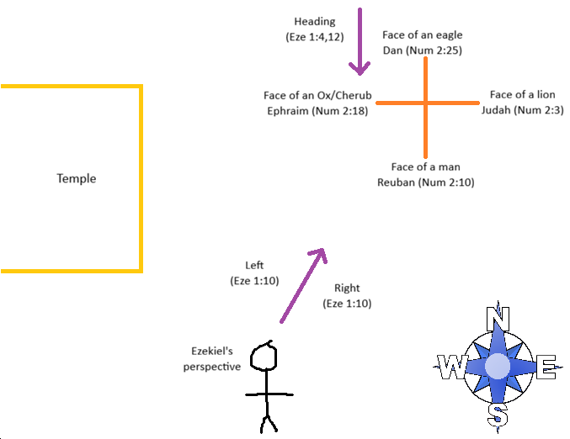

Coincidence? I trow not (Hebrews 10:1)
There is also another interesting “parallel” in the last book of the Bible. In Ezekiel, each of the four living creatures has four faces. But, in Revelation each “face” is it’s own individual beast around the throne of God.

In Ezekiel, each living creature is below the firmament which the throne is inside of (Eze 10:1-4). In Revelation, each beast is around the throne.

Revelation 4:6-7
⁶ And before the throne there was a sea of glass like unto crystal: and in the midst of the throne, and round about the throne, were four beasts full of eyes before and behind.
⁷ And the first beast was like a lion, and the second beast like a calf, and the third beast had a face as a man, and the fourth beast was like a flying eagle.

And assuming these also align with Ezekiel’s vision, and the tribal encampments, they are listed in this order: East, West, South, North.

